Technological University of the Shannon: Midlands Midwest

Faculty of Engineering & Informatics






STUDENT NAME: Mohammad Zain

STUDENT NUMBER: A00326693

ASSIGNMENT TITLE: Smart Door Lock

DATE: 15/11/2025

Contents
Introduction 3
System Purpose and Background 4
System Requirements 5
Functional Requirements 5
Non-Functional Requirements 5
Design 6
Hardware Design 6
Program Flowchart 7
Build & Implementation 8
Hardware 8
Test & Results 9
Conclusion 11

Introduction
Modern security systems have advanced beyond just metal locks and keys for entry. This is because, today, many secured zones are now utilizing automatic identity recognition systems, which respond to the presence of an individual and allow entry only after recognition. This is, in fact, showcased through this small prototype developed here, with the help of an Arduino microcontroller.
The solution integrates motion detection, electronic password entry, rule-driven decision-making, and mechanical control to mimic the operation of an electronically controlled door. The software program also features other safety mechanisms, including idle cancellation and temporary lockdown following failed attempts, bringing the behavior much closer to the real thing.

System Purpose and Background
The objective of this project is to develop and test an efficient access control system, which will respond to the input provided by the environment and will carry out various tasks based on conditions. The proposed prototype illustrates the digital control of secure locations like laboratories, equipment rooms, office rooms, and accommodation buildings.
The system must perform the following functions:
- Recognize that someone is approaching.
- Request and validate a password.
- Act differently for different inputs.
- Opening and closing the door mechanisms automatically.
- Visually and audibly communicate status.
- Protect itself against tampering and guessing attacks.
Contrary to focusing on electronic motion, the emphasis of this project is on decision logic driven by sensors, which is important for safe deployment.

System Requirements

Functional Requirements
The system must:
- Use the PIR sensor to detect human motion.
- Ask the user to enter his/her eight-digit password on the 4x4 keypad.
- Each character entered on the LCD should be masked by “*”.
- The entered password is matched to the predefined, stored password.
- Open and close a dual servo-door mechanism based on successful authentication.
- Flash a red LED, sound a warning tone, and count the attempt during failed authentications.
- Engage the timeout timer mode after three unsuccessful attempts.
- Cancel the password entry if no key is entered within the idle timeout interval.

Non-Functional Requirements
- User Feedback: At all times, the system must show the status on the LCD.
- Reliability: The system should go back to “waiting” status after each event, whether successful, left idle, or denied.
- Safety and Control: Mechanical motion should stay within the servo motor’s angular limits.
- Scalability: The reasoning can be extended to handle more than one password or authenticating module.

Design

Hardware Design
The Arduino board functions as the main processor. The PIR sensor and keypad act as digital inputs, and the servo motors, LEDs, buzzer and LCD (I²C) act as system outputs. Each component connects using different pins as follows:
Component | Type | Purpose | Arduino Pin(s)
PIR Sensor | Input | Detect movement | D4
Keypad (4×4) | Input | Password entry | D6–D13
Servo Motor 1 & 2 | Output | Door movement | A2, A3
Red LED | Output | Closed / denied indicator | D2
Green LED | Output | Granted indicator | D3
Buzzer | Output | Audio feedback | D5
16×2 LCD | Output | Text interface | I²C via library

Program Flowchart
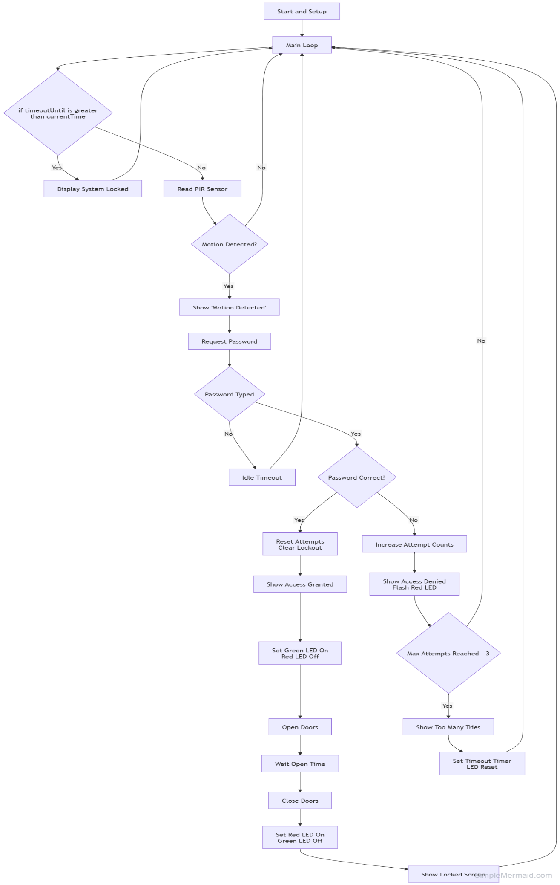

Build & Implementation

Hardware
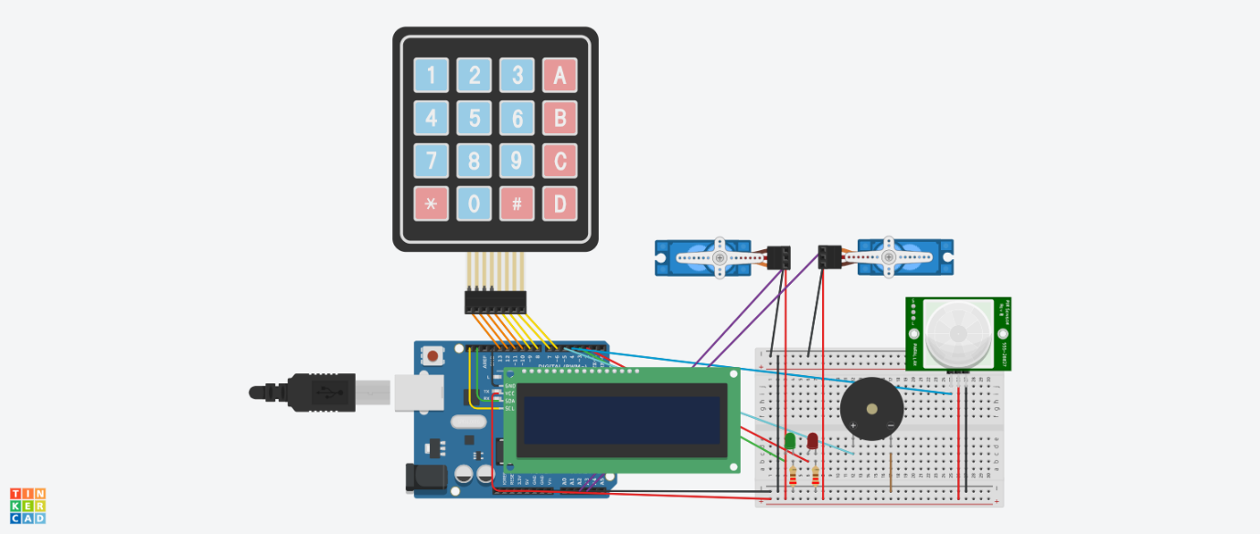

Test & Results
Access Granted (Correct Password) – Doors open, green LED turns on, success tone beeps
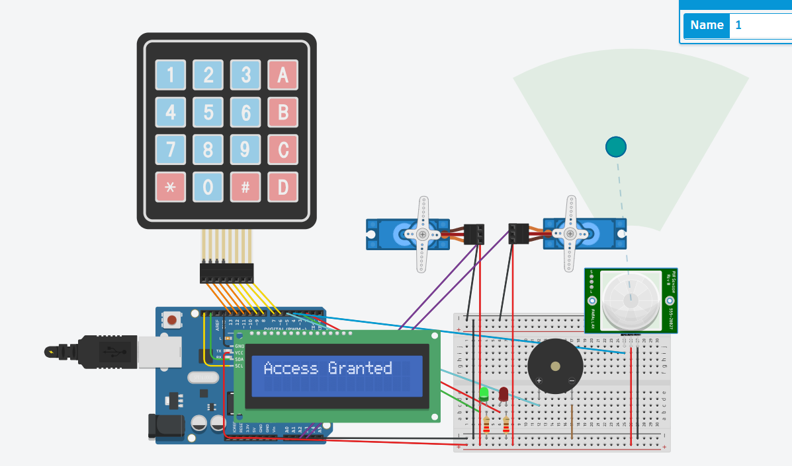
Access Denied (Incorrect Password) – Doors closed, red LED turns on, error tone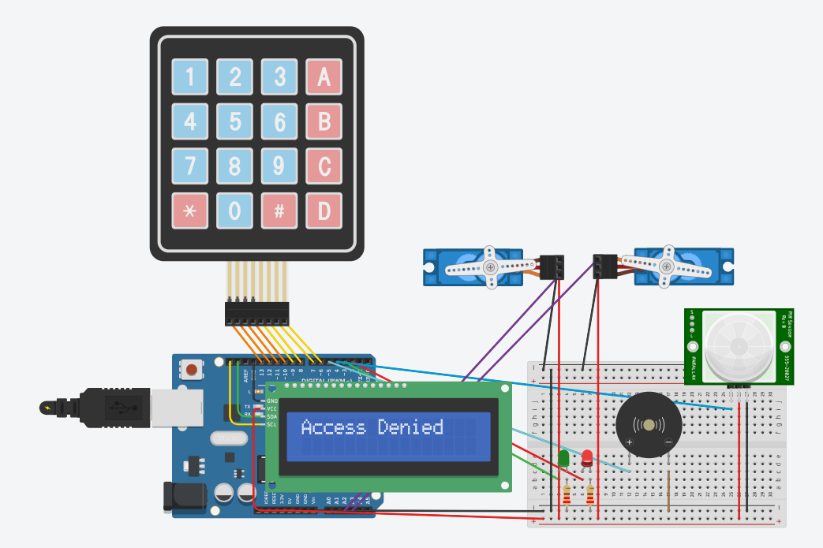

Idle Timeout (No keys pressed) – Login cancelled, returns to idle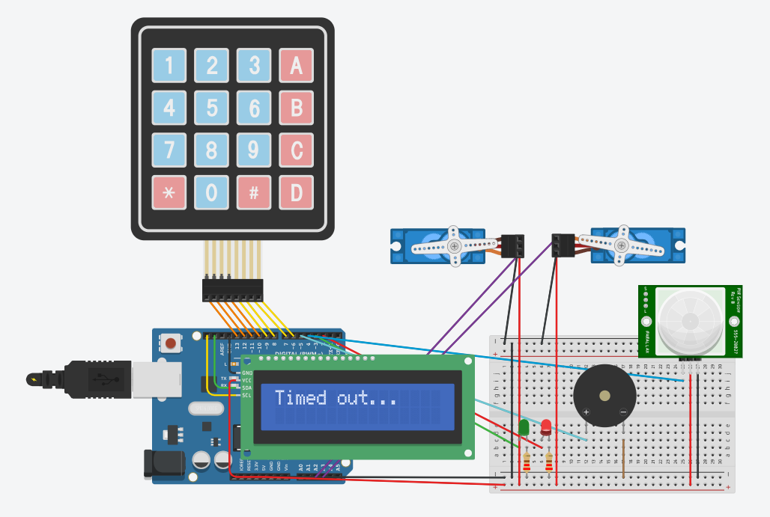

System Locked (Three incorrect attempts) – Timeout message, 60 sec delay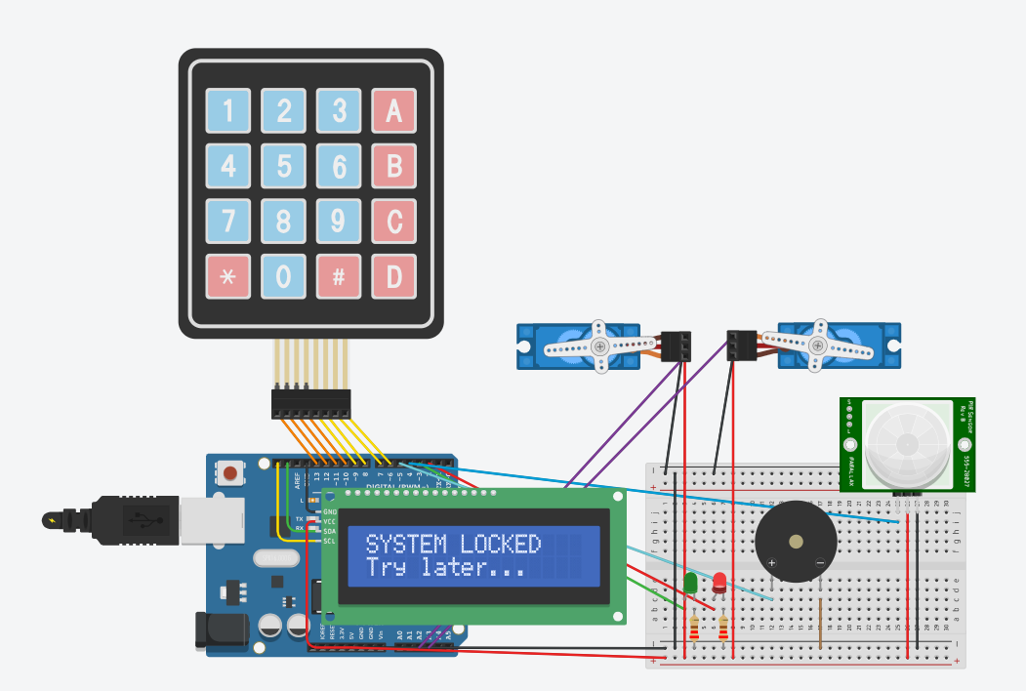

Conclusion
The finished prototype met all functional objectives and successfully demonstrated how an Arduino can control a full input, decision and actuation cycle. It reacted to detected movement, gathered user input, assessed conditions securely, and used audio, visual and mechanical elements to communicate actions and enforce access control.

